\*\*Estimation of Business Expenses\*\*

\*\*1 INTRODUCTION\*\*

\*\*1.1 Overview\*\*

Our project "Estimation of Business Expenses" focuses on estimating the expenses of an organization for a particular year. The project aims to provide a reliable estimation of the expenses incurred by the organization to aid in budgeting and financial planning. The project involves creating visualizations to represent the overall expenses in a clear and understandable manner.

\*\*1.2 Purpose\*\*

The purpose of this project is to assist organizations in accurately estimating their expenses for a specific year. By providing a comprehensive estimation, businesses can make informed decisions regarding resource allocation, cost management, and financial forecasting, budgeting and planning. The visualizations help stakeholders gain insights into the distribution and trends of the expenses, enabling better financial planning and decision-making.

\*\*2 LITERATURE SURVEY\*\*

\*\*2.1 Existing Problem\*\*

Existing methods of estimating business expenses often rely on manual calculations and general assumptions such as Historical Data Analysis, Top-Down Approach, Bottom-Up Approach, Benchmarking, Predictive Analytics etc. The lack of automated tools for expense estimation hinders organizations' ability to effectively plan their budgets and manage their finances. Furthermore, the absence of visualizations makes it challenging to comprehend the overall expenses and identify patterns or anomalies.

\*\*2.2 Proposed Solution\*\*

The suggested approach involves utilizing visualizations to estimate business expenses effectively. By leveraging historical expense data, industry benchmarks, and relevant financial indicators, the solution aims to generate precise expense estimates. Additionally, the use of visualizations will enable stakeholders to easily comprehend the overall distribution of expenses, enhancing their understanding of the financial landscape. Using web app, it clears all the confusion about the expenses. We’ve also used flask framework to deploy website by deploying the visualizations.

\*\*3 THEORETICAL ANALYSIS\*\*

``` 3.1 Block diagram

Diagrammatic overview of the project.

\*\*3.2 Hardware / Software Designing\*\*

Hardware Requirements:

- The hardware requirements for designing can vary depending on the complexity of the data and the scale of the project. Here are the general requirements such as:

1. CPU (core i5)
2. RAM (8 GB)
3. Graphics Card

Etc..

Software Requirements:

- Here are the software requirements for designing the project. We need Programming languages such as: HTML, CSS, JS, PHP, Python (Flask) for Web app and deploying the web app using Flask. To create visualizations, we need Tableau through we can create visualizations, interactive dashboards and stories.

\*\*4 EXPERIMENTAL INVESTIGATIONS\*\*

The project involves the following experimental investigations:

- Data Collection: Gathering historical expense data from the organization, including details such as expense categories, amounts, and timestamps.

- Data Preprocessing: Cleaning and transforming the expense data to ensure consistency and accuracy for further analysis.

- Visualization Design: Designing visualizations, such as bar charts, pie charts, and line plots, to represent the overall expenses and highlight important patterns or trends.

\*\*Flowchart\*\*

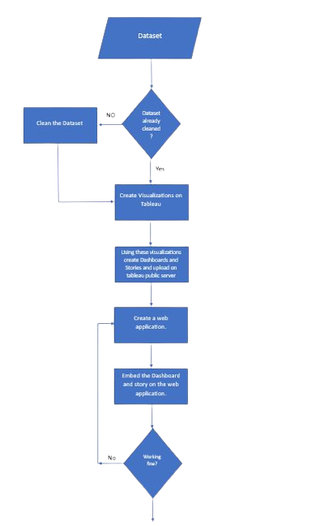

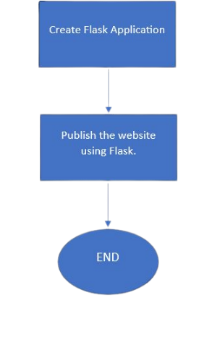

\*\*6 RESULT\*\*

The final result of the project is an estimation of business expenses with visually appealing and informative visualizations representing the overall expenses. The expense estimation provides organizations with an accurate understanding of their projected expenses, and the visualizations facilitate better interpretation of the expense patterns and trends.

Here are the screenshots of the project:

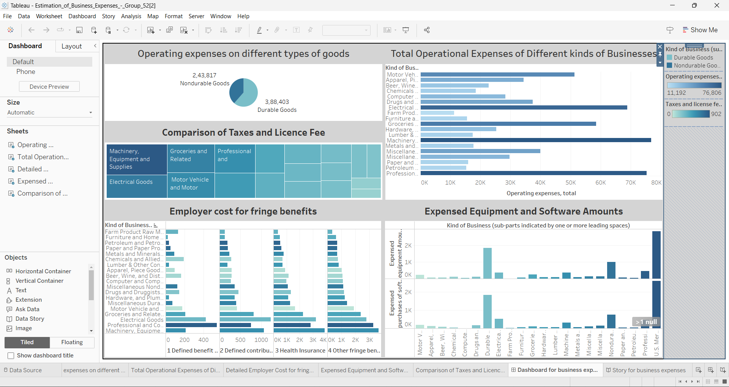

Dashboard

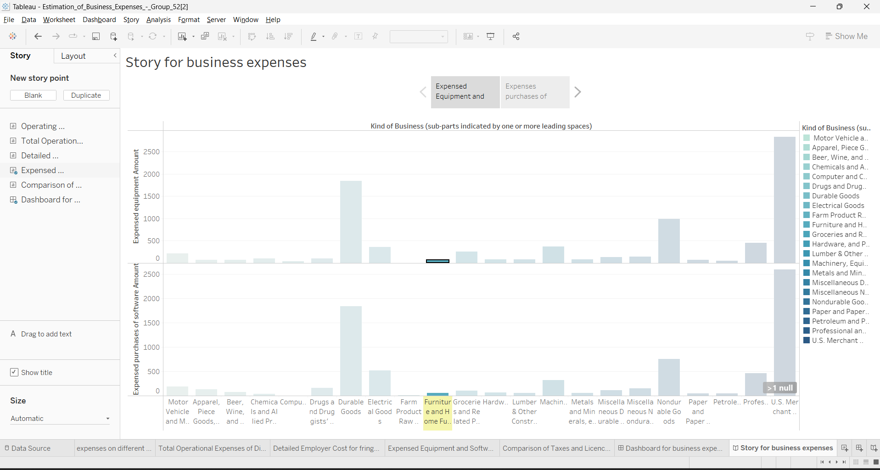

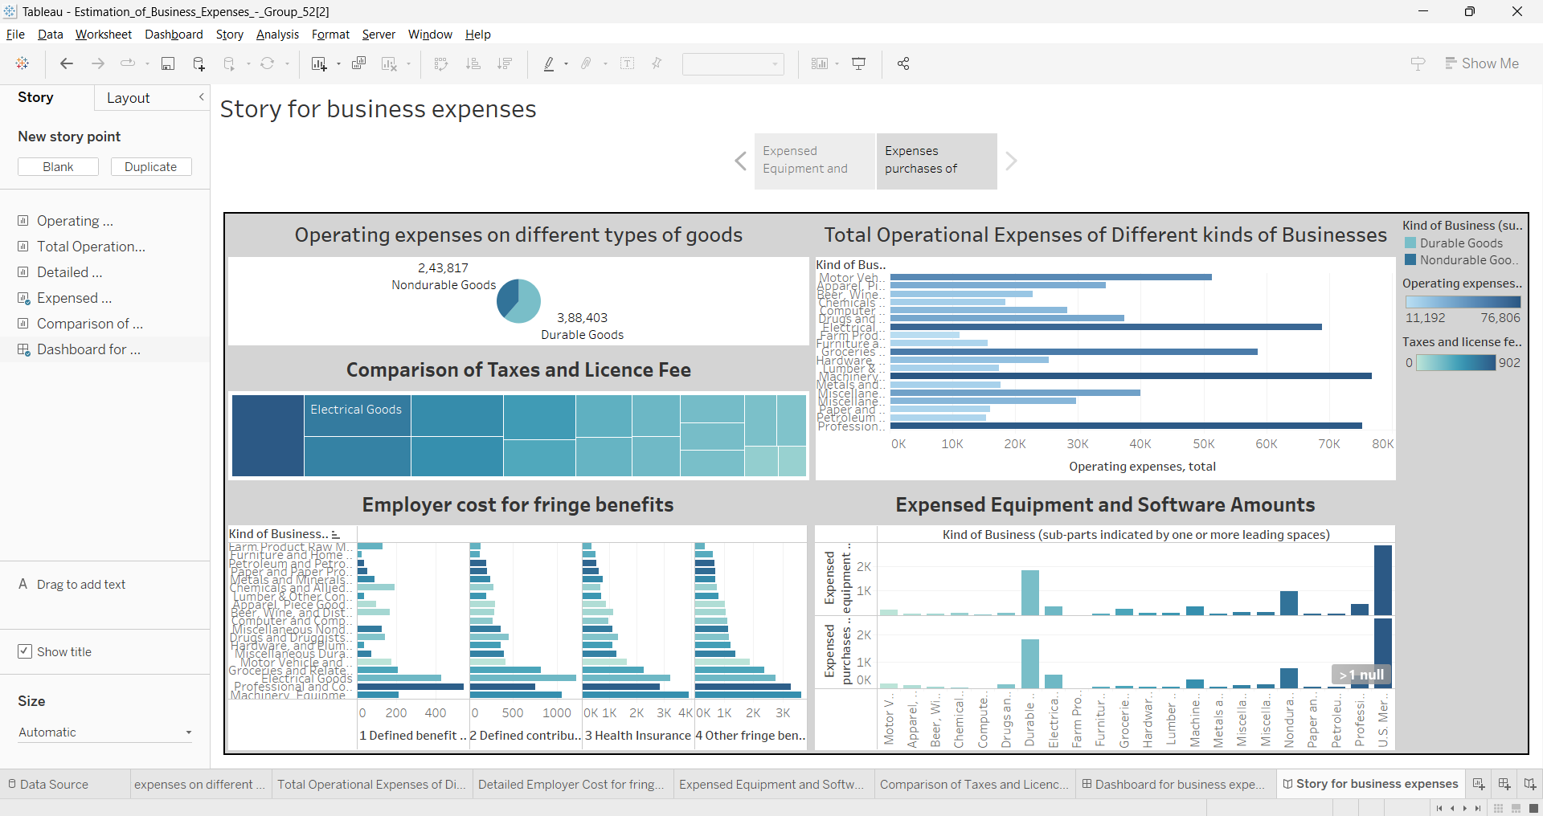

Story

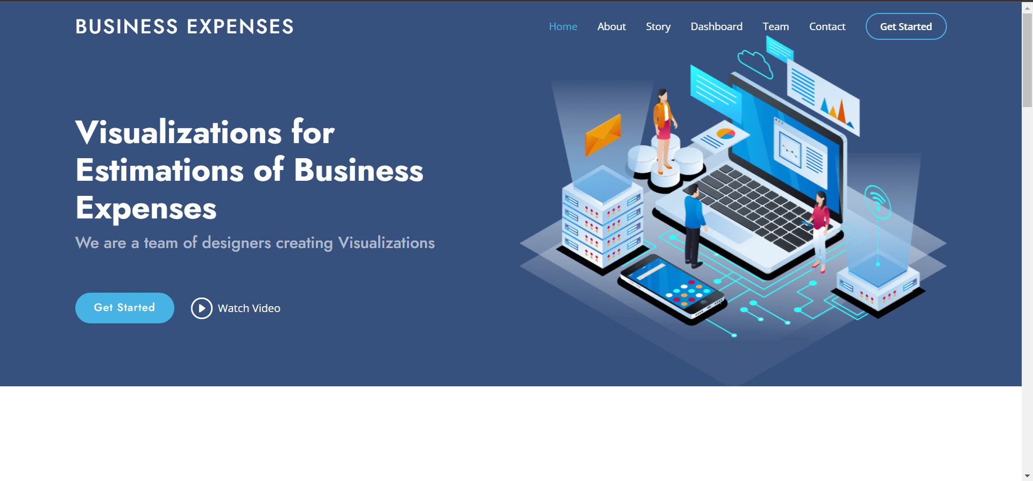

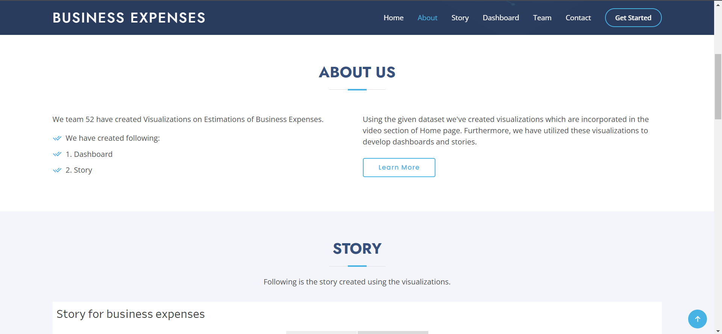

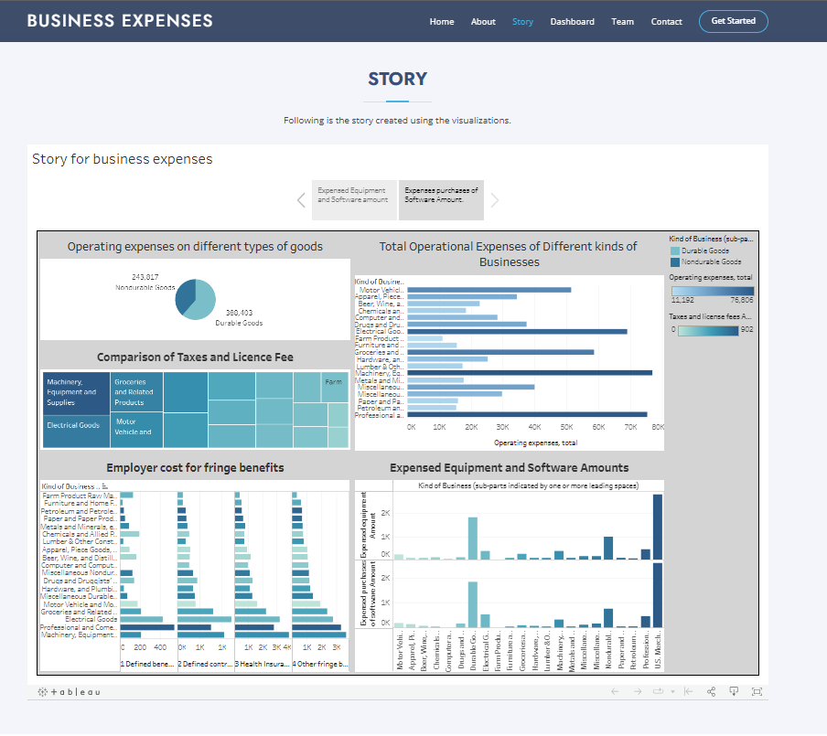

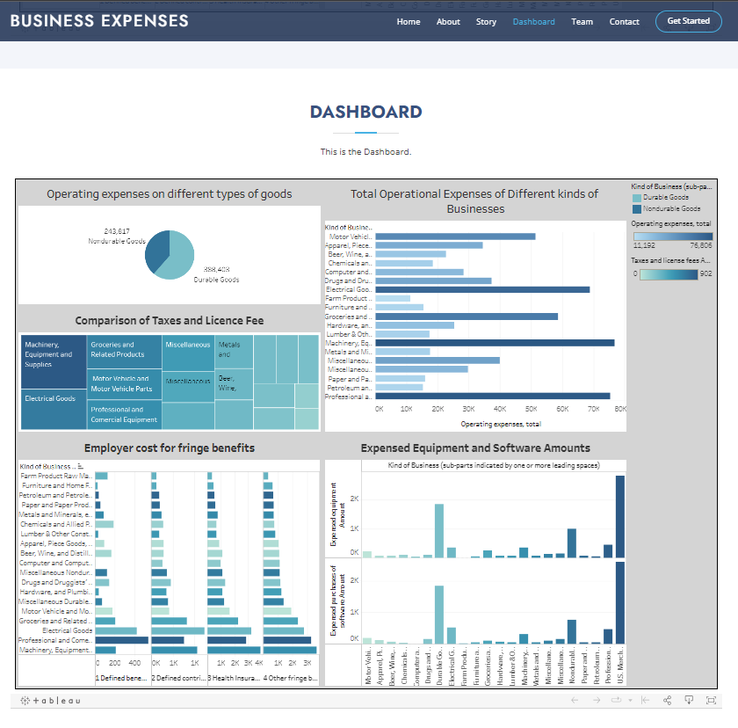

Website

\*\*7 ADVANTAGES & DISADVANTAGES\*\*

Advantages of the proposed solution:

- Accurate Expense Estimation: The system leverages historical expense data and relevant financial indicators to generate reliable expense estimates.

- Efficient Financial Planning: Organizations can utilize the expense visualizations to plan their budgets, allocate resources effectively, and make informed financial decisions.

- Improved Visualization: The visualizations enhance the understanding of expense patterns and trends, enabling stakeholders to identify cost-saving opportunities and anomalies.

Disadvantages of the proposed solution:

- Data Dependency: The accuracy of the expense estimation heavily relies on the availability and quality of historical expense data.

\*\*8 APPLICATIONS\*\*

The proposed solution can be applied in various business contexts, including:

- Financial Management, Budget Planning: Organizations can utilize the expense estimation and visualizations to gain insights into their financial status, analyze cost drivers, and optimize their spending.

- Stakeholder Communication: The visualizations can be used to effectively communicate expense-related information to stakeholders, facilitating discussions and decision-making processes.

\*\*9 CONCLUSION\*\*

The project "Estimation of Business Expenses" focuses on providing organizations with accurate expense estimations for a particular year. The visualizations enhance the interpretation of the overall expenses, aiding stakeholders in financial planning and decision-making processes. The project's findings demonstrate the potential visualization techniques in improving financial management.

\*\*10 FUTURE SCOPE\*\*

Future enhancements for the project include:

- Integration of Real-Time Data: Incorporating real-time data sources to adapt the expense estimation to dynamic business conditions and enable up-to-date financial planning.

- Advanced Visualization Techniques: Exploring interactive and advanced visualization methods, such as heatmaps, to provide more comprehensive insights into expense patterns.

- Integration with Financial Systems: Developing integrations with existing financial systems or accounting software to streamline the expense estimation process and enhance data accuracy.